**POWER BI**

https://www.youtube.com/watch?v=KoDSDZr_l1g&list=PLbMVPNscUopQQsNiTDkxnMfR68i8RPHYK&index=6

**POWER BI HISTORY**

**What is Power BI:--**

Power BI is a business analytics service by Microsoft that allows users to visualize and analyze data from various sources, creating interactive dashboards and reports.

**Key Features of Power BI**

1. Data Connectivity: Connect to various data sources, including Excel, SQL Server, Azure, and more.

2. Data Modeling: Create data models to define relationships between data sources.

3. Data Visualization: Create interactive and dynamic visualizations, such as charts, tables, maps, and more.

4. Dashboarding: Combine multiple visualizations into a single dashboard to provide a comprehensive view of the data.

5. Reporting: Create reports to share insights and findings with others.

6. Artificial Intelligence (AI): Use AI-powered features, such as automated machine learning and natural language processing.

**Benefits of Using Power BI**

1. Improved Decision-Making: Make data-driven decisions with interactive and dynamic visualizations.

2. Enhanced Collaboration: Share insights and findings with others, and collaborate in real-time.

3. Increased Productivity: Automate reporting and analysis tasks, and focus on higher-level tasks.

4. Scalability: Handle large datasets and scale to meet the needs of your organization.

**Who Uses Power BI?**

1. Business Analysts: Use Power BI to analyze data and create visualizations to present insights to stakeholders.

2. Data Scientists: Use Power BI to connect to various data sources and create interactive visualizations.

3. Business Intelligence Developers: Use Power BI to create dashboards and reports for stakeholders.

4. IT Professionals: Use Power BI to manage and deploy BI solutions within their organization.

**Power BI Products**

1. Power BI Desktop: A free, self-service analytics platform for creating and publishing visualizations.

2. Power BI Pro: A cloud-based platform for sharing and collaborating on visualizations and dashboards.

3. Power BI Embedded: A platform for embedding Power BI visualizations and dashboards into custom applications.

4. Power BI Mobile: A mobile app for accessing and interacting with Power BI visualizations and dashboards on-the-go.

**POWER BI INTRODUCTION:**

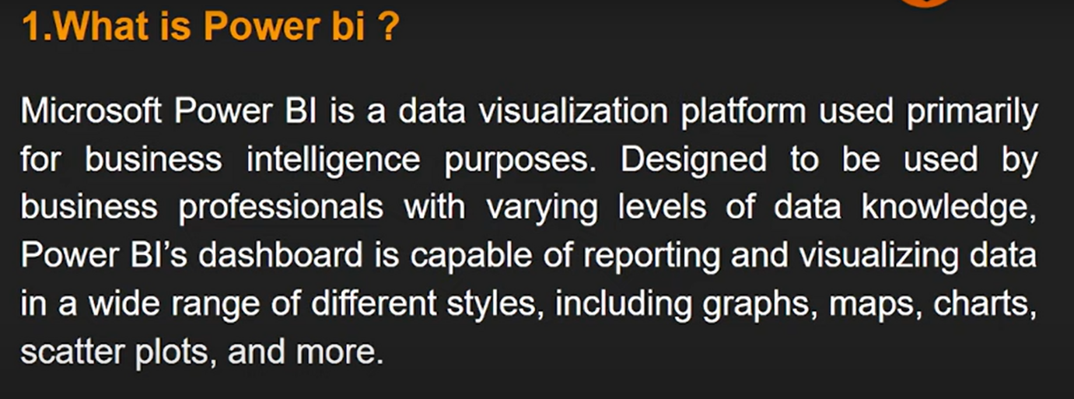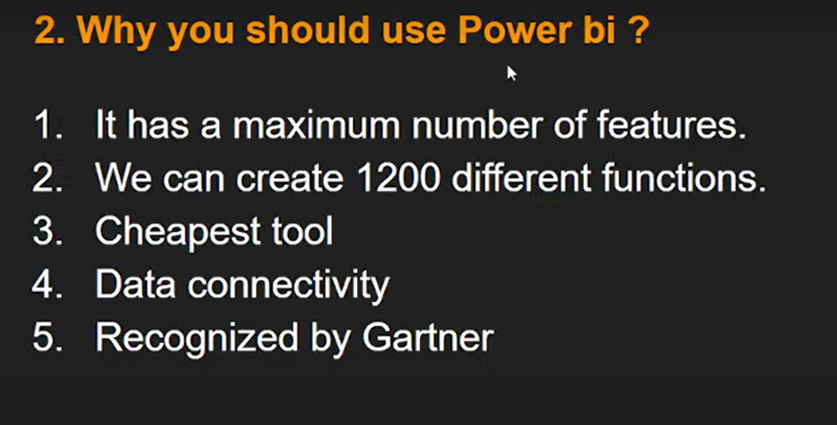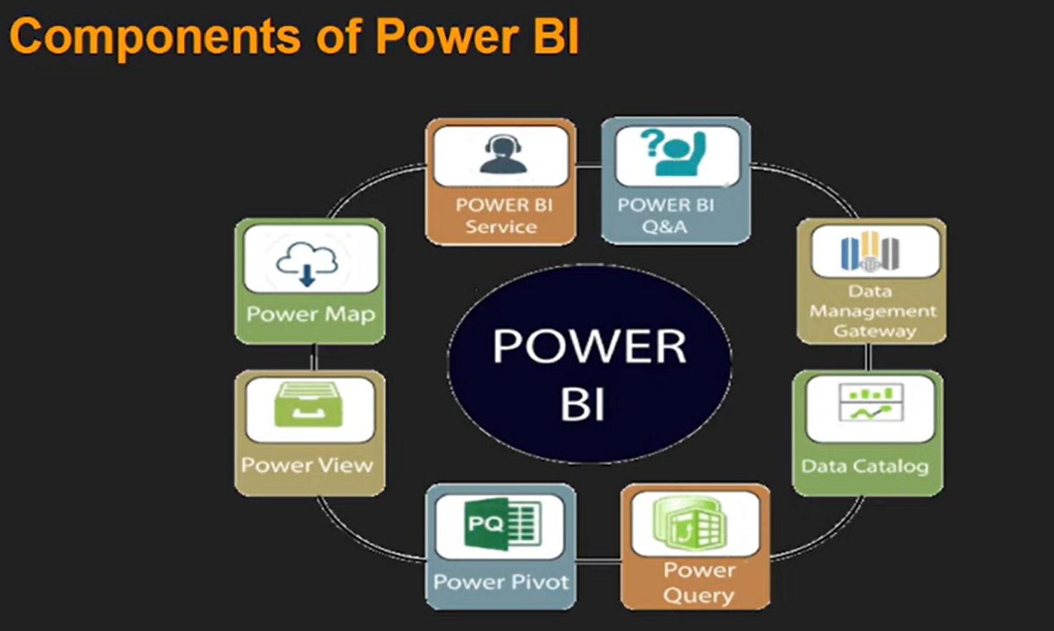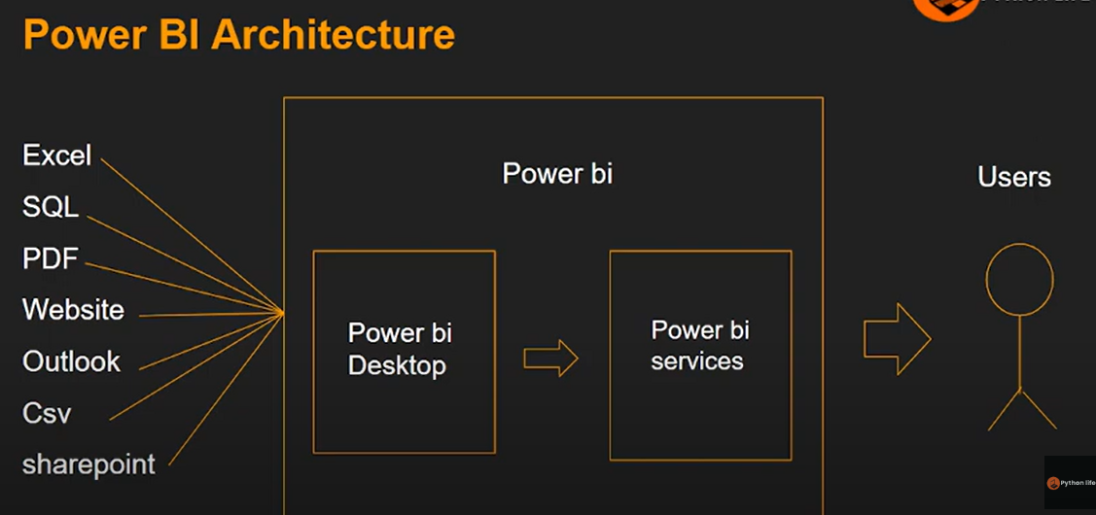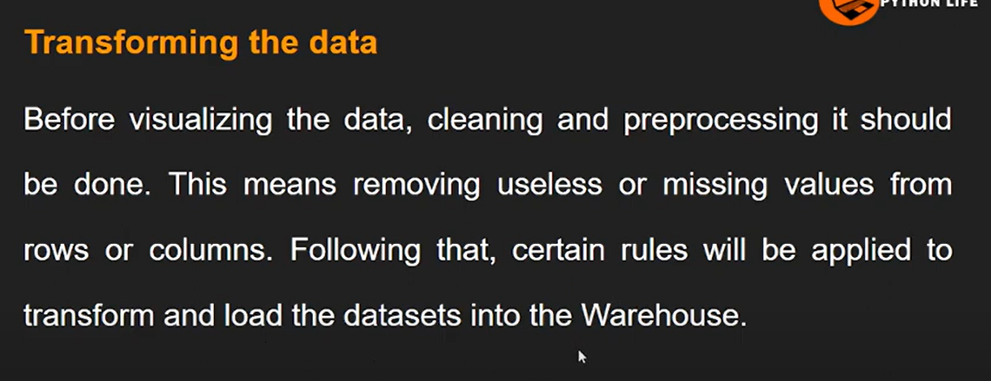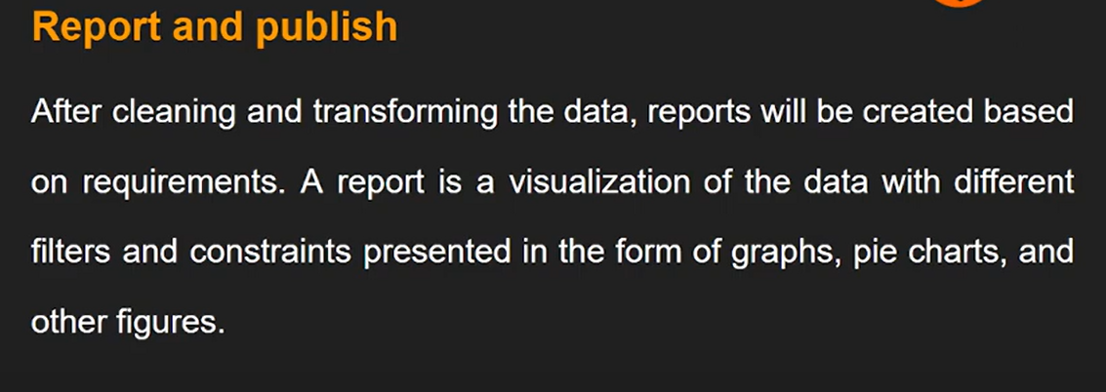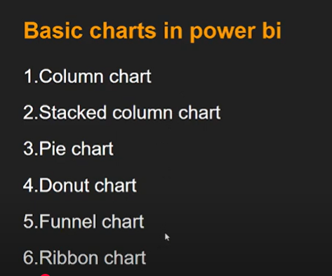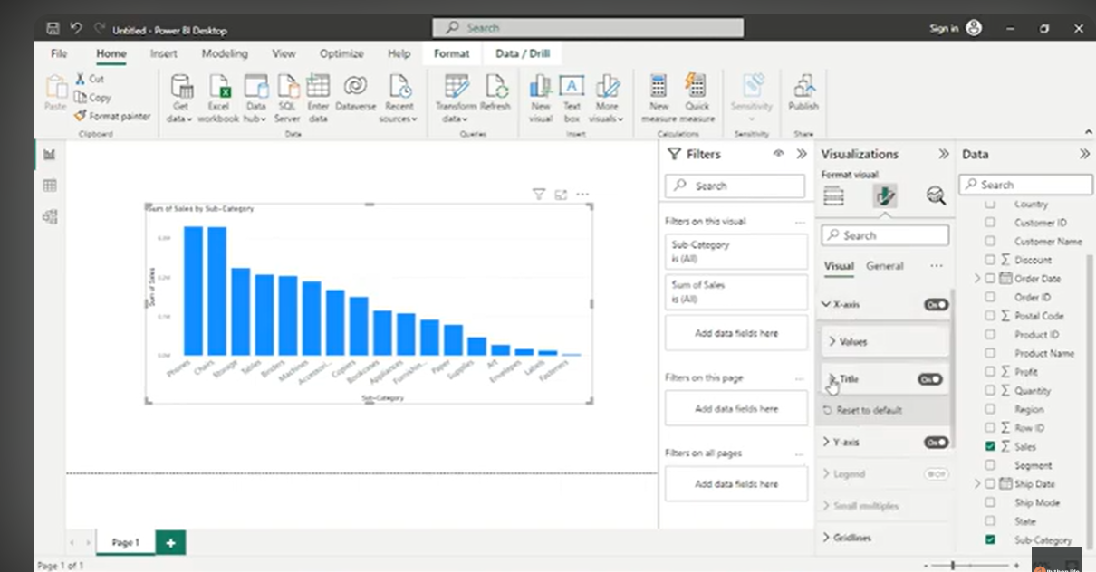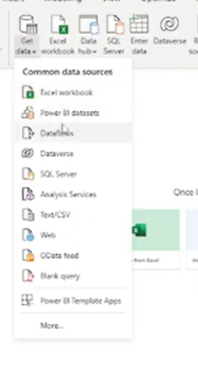**Filters on visuals**

